

IRF21/2476

Gateway determination report – PP-2021-3881
Rezone and reduce the minimum lot size of land at Willow Run, 105 -119 Bong Bong Road, Mittagong (part Lot 115 DP 1067955)
June 21

Published by NSW Department of Planning, Industry and Environment
dpie.nsw.gov.au
Title: Gateway determination report – PP-2021-3881
Subtitle: Rezone and reduce the minimum lot size of land at Willow Run, 105 -119 Bong Bong Road, Mittagong (part Lot 115 DP 1067955)
© State of New South Wales through Department of Planning, Industry and Environment 2021. You may copy, distribute, display, download and otherwise freely deal with this publication for any purpose, provided that you attribute the Department of Planning, Industry and Environment as the owner. However, you must obtain permission if you wish to charge others for access to the publication (other than at cost); include the publication in advertising or a product for sale; modify the publication; or republish the publication on a website. You may freely link to the publication on a departmental website.
Disclaimer: The information contained in this publication is based on knowledge and understanding at the time of writing (June 21) and may not be accurate, current or complete. The State of New South Wales (including the NSW Department of Planning, Industry and Environment), the author and the publisher take no responsibility, and will accept no liability, for the accuracy, currency, reliability or correctness of any information included in the document (including material provided by third parties). Readers should make their own inquiries and rely on their own advice when making decisions related to material contained in this publication.

Contents
1 Planning proposal 1
1.1 Overview 1
1.2 Objectives of planning proposal 1
1.3 Explanation of provisions 2
1.4 Site description and surrounding area 2
1.5 Background 5
1.6 Mapping 6
2 Need for the planning proposal 6
3 Strategic assessment 7
3.1 Regional Plan 7
3.2 Local 8
3.3 Section 9.1 Ministerial Directions 10
3.4 State environmental planning policies (SEPPs) 11
4 Site-specific assessment 12
4.1 Environmental 12
4.2 Social and economic 13
4.3 Infrastructure 14
4.4 Community 14
4.5 Agencies 14
5 Timeframe 14
6 Local plan-making authority 14
7 Assessment summary 14
8 Recommendation 14

Table 1 Reports and plans supporting the proposal
Relevant reports and plans
Planning Proposal (Version 2, June 2021)
Report to Council (26 August 2020)
Resolution of Council (26 August 2020)
Ecological Constraints Assessment (December 2018)
Heritage Impact Assessment Report and Photographs (March 2021)
Visual Assessment Report (October 2017)
Preliminary Contamination Assessment (October 2020)

Planning proposal

Overview
Table 2 Planning proposal details
LGA | Wingecarribee Shire Council
PPA | Wingecarribee Shire Council
NAME | Willow Run Planning Proposal (12-15 homes, 0 jobs)
NUMBER | PP-2021-3881
LEP TO BE AMENDED | Wingecarribee Local Environmental Plan 2010
ADDRESS | 105-119 Bong Bong Road, Mittagong
DESCRIPTION | Part Lot 115 DP 1067955
RECEIVED | 11/06/2021
FILE NO. | IRF21/2476
POLITICAL DONATIONS | There are no donations or gifts to disclose and a political donation disclosure is not required
LOBBYIST CODE OF CONDUCT | There have been no meetings or communications with registered lobbyists with respect to this proposal

Objectives of planning proposal
The planning proposal contains objectives and intended outcomes that adequately explain the intent of the proposal.
The objectives of the planning proposal are to:
- amend the relevant Land Zoning Map in the Wingecarribee LEP to rezone part of Lot 115 DP 1067955 to R5 Large Lot Residential; and
- amend the relevant Lot Size Map of Wingecarribee LEP to apply a minimum lot size of 4,000m² to part of Lot 115 DP 1067955.
The proposed amendments would create the ability to subdivide the land for residential development, subject to development consent.

Explanation of provisions
The planning proposal seeks to amend the Wingecarribee LEP 2010 per the changes below:
Table 3 Current and proposed controls
Control | Current | Proposed
Zone | RU2 Rural Landscape | R5 Large Lot Residential
Minimum lot size | 40ha | 4,000m²
Floor Space Ratio | None | No change
Height of Building | None | No change
Number of dwellings | 0 | 12-15
The planning proposal contains an explanation of provisions that adequately explains how the objectives of the proposal will be achieved.

Site description and surrounding area
The site lies on the south eastern edge of Mittagong Township in the Wingecarribee local government area (Figure 1).
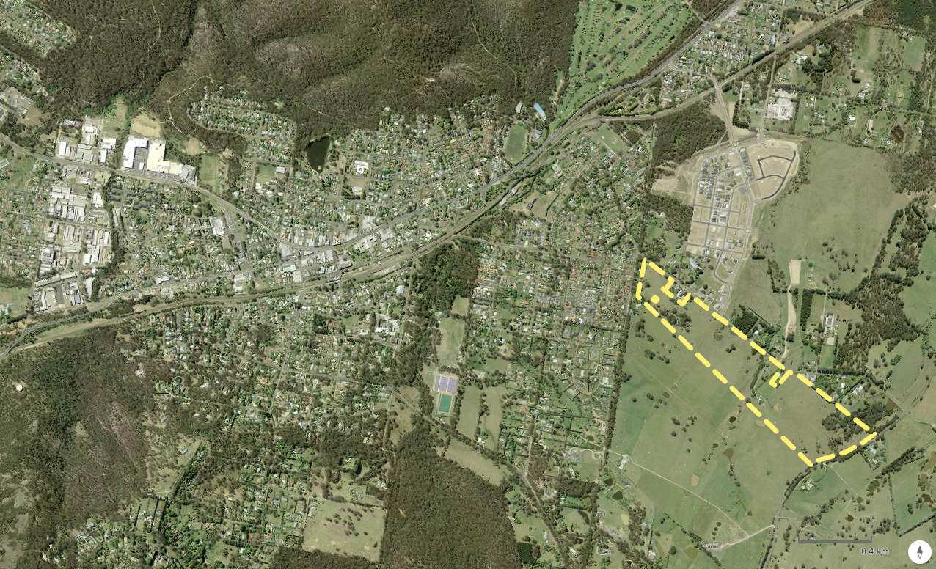
Site
Mittagong
Figure 1: Site Context (Source: DPIE Spatial Viewer)
The site is legally described as Lot 115 DP 1067955, is located at 105-119 Bong Bong Road, Mittagong and is approximately 36ha in size.
The planning proposal applies the north-west portion of Lot 115 DP 1067955 only which is illustrated (indicatively) in Figure 2 below (see ‘Proposed Development Area’) and is about 8ha in area.
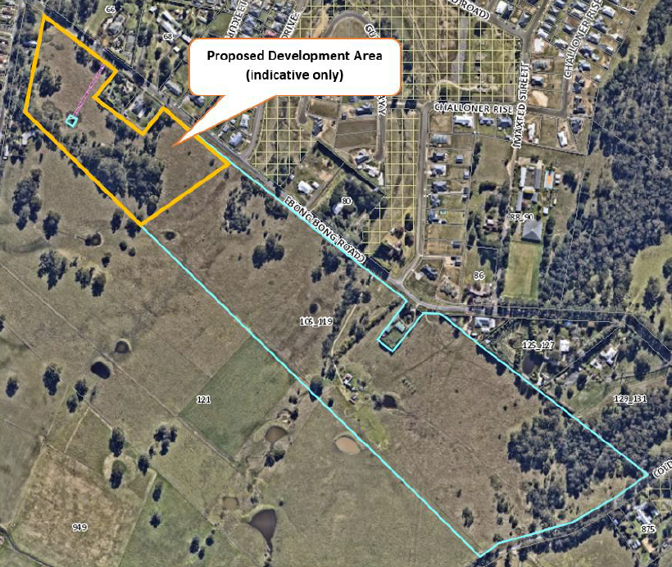
Renwick Urban Release Area
Figure 2: Site context (Source: Planning Proposal)
The site is a long rectangular shape running generally on an east-west alignment between Mary Street to the west and Old South Road to the east. The site is approximately 1,300m long and 260m deep.
It is predominately open grazing land with an old farmhouse located on site. The land has a combination of Class 3 and Class 4 agricultural land classification, meaning that it is suitable for some pasture improvement and limited grazing.
The topography of the site is gently undulating with moderate slopes rising both to the east and the west from a low point towards the centre of the site almost directly opposite the intersection of Bong Bong Road and Renwick Drive.
The adjoining land to the south gets steeper the further south it extends and as a result, is more visually prominent than the subject site.
Natural drainage channels from the catchment of higher ground to the south continue in a northerly direction across the site and into the Renwick Urban Release Area on the opposite side of Bong Bong Road.
The part of the site proposed for rezoning is currently zoned RU2 Rural Landscape under Wingecarribee Local Environmental Plan 2010 with a minimum lot size of 40ha.
The rezoning site contains two key vegetation communities (Figure 7), namely Southern Highlands Shale Woodland (SHSW) and Exotic Grassland. SHSW is listed as a Critically Endangered Ecological Community under the Commonwealth Environmental Protection and Biodiversity Conservation (EPBC) Act 1999, and as an Endangered Ecological Community under the State Biodiversity Conservation Act 2016.
The broader site is also mapped as bushfire prone and flood liable land (although the proposed rezoning site outside the mapped flood area) – Figure 3 and Figure 4.
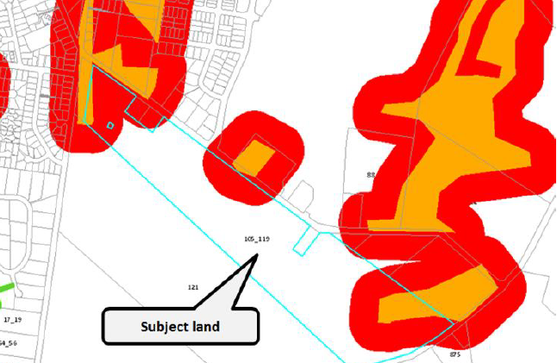
Figure 3: Bushire Prone Land Map (Source: Planning Proposal)
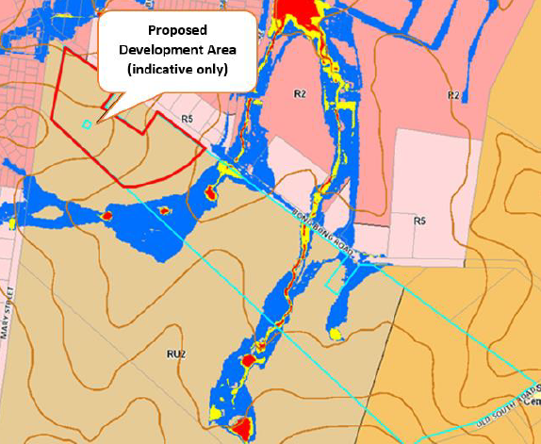
Figure 4: Flood Liable Land Map (Source: Planning Proposal)
The site is also mapped as a local heritage item in Schedule 5 of the LEP. Council has advised the identified heritage features are the “wells, barn and outbuildings” which are located further east, away from the proposed residential area.
Several heritage-listed properties are also located along the northern side of Bong Bong Road opposite the site. These items, combined with their location within the rural landscape, create an informal local heritage precinct along Bong Bong Road. Rowe Cottage, Challoner Cottage and Goodlet Cottage all relate to the Former Renwick Institution of which the silos will remain heritage listed even after the remainder of the Renwick Urban Release Area is developed.

Background
Council has advised the entire site, including the E3 portion and adjoining land (Lot 2 Mary Street, Rushford Barton and Lynwood) were the subject of previous rezoning applications in 2007 and 2008 during the drafting of Wingecarribee LEP 2010. Council resolved that the zoning and minimum lot size remain unchanged, but that the sites be included for further investigation in the Wingecarribee Local Planning Strategy 2015-2031. Council has advised that at the time, it identified the maximum extent to which it would consider any future residential development proposal (an area which generally corresponds with the proposed development area in this planning proposal).

A planning proposal which included the subject site (Willow Run) and adjoining land was considered during the preparation of the Wingecarribee Local Planning Strategy 2015-2031. On 23 March 2016, Council resolved to rezone the adjacent Lot 2 Mary Street to R5 Large Lot Residential with a minimum lot size of 4000m² but the remaining lots, including the subject site, were not supported for rezoning due primarily to the fact that their entire area was proposed for rezoning rather than just Willow Run.

In October 2017, a planning proposal was submitted to Council for the entire lot which sought to rezone the entire RU2 Rural Landscape portion of the site to R2 Low
Density Residential and apply minimum lot sizes ranging between 450m² and 1000m². The proposal was not supported by Council at its meeting of 9 May 2018. At this time, Council re-confirmed the original boundary of an area it would be prepared to consider for potential residential development on the Willow run site (Figure 5). This is an area of approximately 8ha.
Figure 5: Extent of potential residential area identified in 2018 (Source: Planning Proposal)
A new planning proposal was then submitted to Council in February 2019 seeking to rezone part of the site R2 Low Density Residential with a minimum lot size ranging from 600m² to 2,000m². The proponent subsequently requested that consideration of the Planning Proposal be deferred until the Wingecarribee Local Housing Strategy was adopted by Council which occurred on 24 June 2020.

On 26 August 2020, Council resolved not to support the proposed rezoning to R2 Low Density Residential, but instead that rezoning to R5 Large Lot Residential with a minimum lot size of 4000m² be supported. This was largely because R5 zoning would enable a scale/density of residential development better situated to the locality and the ecological constraints of the site and due to the potential traffic infrastructure implications of allowing lots smaller than 1,000m².

This planning proposal responds to Council’s resolution of 26 August 2020.

Mapping
The planning proposal does not include mapping showing the proposed changes to the Wingecarribee LEP 2010 maps.
A Gateway condition is recommended requiring existing and proposed draft LEP maps to be prepared and exhibited with the planning proposal.

Need for the planning proposal
Council considers the Planning Proposal responds to Council’s Local Planning Strategy 2015 -2031, adopted on 23 March 2016.
Council states the Local Planning Strategy 2015-2031 supported residential development of a portion of the subject site (although the Department notes the final resolution of Council on 23 March 2016 recommended the site remain zoned RU2 Rural Landscape with a minimum lot size of 40ha).
It is noted that Chapter 4 addressing the Shire’s future housing needs was not endorsed by the Department which advised Council that reliance on meeting the future housing needs should not rely on infill development alone.
The subject land is also identified as part of the Mittagong (East) ‘New Living Area’ in the Wingecarribee Local Housing Strategy (LHS) adopted by Council on 24 June 2020 to meet the Shire’s future housing needs. It is noted that to date the LHS has not been submitted to the Department for endorsement.
The proposal is also consistent with Chapter 4 of Council’s adopted Local Strategic Planning Statement and Planning Priorities 4.2 and 4.3 which seek to improve housing affordability and provide land and housing opportunities to meet the needs of the community.
Council considers the planning proposal provides an opportunity to achieve its strategic planning goals of providing additional housing opportunities across the Shire, including both infill and green field development opportunities.
The planning proposal is the only way of achieving the objectives and intended outcomes. Council could not accept, nor support a development application for the subdivision of the land without the proposed amendments to LEP in place.
The Department acknowledges the proposal is supported by, and the result of, Council’s local strategic planning processes/strategies and would contribute to meeting the Shire’s future housing needs.

Strategic assessment

Regional Plan
The following table provides an assessment of the planning proposal against relevant aspects of the South East and Tablelands Regional Plan.
Table 4 Regional Plan assessment
Regional Plan Objectives | Justification
Direction 8 – Protect important agricultural land | The land has a combination of Class 3 and Class 4 agricultural land classification, meaning that it is suitable for some pasture improvement and limited grazing only.  Additionally, only a portion of the site is proposed for rezoning leaving the remainder of the site for ongoing agricultural use.
Direction 14 – Protect important environmental assets | The proposal is supported by an Ecological Assessment which indicates it will likely result in some impacts/clearing of scattered Southern Highlands Shale Woodland which is an Endangered Ecological Community.  This issue is discussed in detail in Section 4.1 of this report.  It is noted the site has been strategically identified/earmarked by Council for residential development for some time.  On balance, ecological impacts can be appropriately managed or offset in the context of providing for the future housing needs of the Wingecarribee community.  Consultation is recommended with DPIE – Environment, Energy and Science to ensure biodiversity issues are thoroughly considered prior to rezoning.
Direction 16 – Protect the coast and increase resilience to natural hazards | Natural bushfire and flooding hazards impacting the site will be appropriately considered as part of the rezoning, including referral to the NSW Rural Fire Service and DPIE – Environment, Energy and Science.  Bushfire and flooding impacts would also be further appropriately considered in detail by Council at the development assessment stage.
Direction 23 – Protect the regions heritage | Council noted the identified heritage features of the site including the “wells, barn and outbuildings” are located further east, away from the proposed residential area. This includes the main homestead building.  The proposal is supported by a European heritage impact assessment which recommends (amongst other things) a reduced heritage curtilage for the site to allow for its development whilst retaining the heritage value of the site and acknowledging its former uses (dairy, beef and fruit producing property).  Council advised the heritage listing should not be considered significant to the assessment of the proposal and noted the remaining heritage aspects of the property would need to be incorporated into any future development scheme for the site.  Council considered the development of Renwick to the north as a case in point where several local items within and adjoining the site have been successfully integrated into the broader development scheme without detriment to their heritage value.  The planning proposal does not identify any potential Aboriginal cultural heritage issues associated with the proposal.  A full/more detailed heritage assessment (with likely consideration of Aboriginal cultural heritage) and the existing heritage provisions of the LEP (which would continue to conserve the significance of the site) would be undertaken at the development assessment stage to ensure all heritage issues are appropriately considered and managed.  On balance, potential heritage impacts will be considered in more detail at later stages and are likely to be manageable in the context of providing for the future housing needs of the Wingecarribee community.
Direction 24 – Deliver greater housing choice and supply | The proposal would provide additional housing to meet community needs contributing to greater housing choice and supply in the Shire.
Direction 25 - Focus housing growth in locations that maximise infrastructure and services | Council considers the proximity of the site to Renwick to the north provides opportunities to leverage off infrastructure and services already available in the locality. Further, the site is considered close enough to Mittagong to encourage the use of all existing services that it has to offer.
Direction 28 – Manage rural lifestyles | The proposal would provide large lot/rural housing opportunities close to existing settlements. Environmental, bushfire, flooding and agricultural constraints have/would be appropriately addressed and managed.

Local
The proposal states it is consistent with the following local plans and strategies.
Table 5 Local strategic planning assessment
Local Strategies | Justification
Local Strategic Planning Statement (LSPS) | The proposal is consistent with Chapter 4 of Council’s adopted Local Strategic Planning Statement and Planning Priorities 4.2 and 4.3 which seek to improve housing affordability and provide land and housing opportunities to meet the needs of the community.  A condition is recommended for the planning proposal to be updated prior to exhibition to address Council’s LSPS.
Local Housing Strategy (LHS) | The subject site formed part of the much larger Mittagong (East) ‘investigation area’ in the LHS (Figure 6) incorporating the Rushford Barton and Lynwood properties to the south.  The LHS analysis confirmed there were several constraints across parts of the investigation area including riparian areas, Endangered Ecological Communities, flooding, a heritage item and potentially contaminated land, and although other parts of the investigation area were not so constrained, they were highly visible from Old South Road and the Renwick residential area.  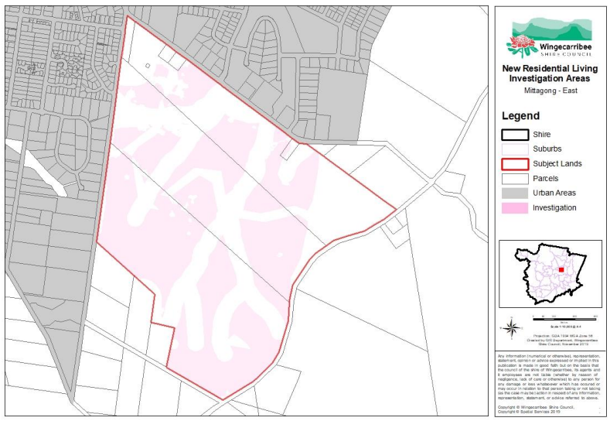  Figure 6: Mittagong (East) Investigation Area (Source: LHS)  Based on the limitations identified in the constraints analysis, the broader investigation area was ultimately deemed unsuitable as a future living area. However, the LHS acknowledged that “a small area has previously been identified for residential development in the north western corner of the site and this Strategy maintains this area as a potential residential area.”  As such, an area which generally corresponds with the subject site was identified as part of the Mittagong (East) ‘New Living Area’ (Figure 7) in the Wingecarribee Local Housing Strategy (LHS) adopted by Council on 24 June 2020 to meet the Shire’s future housing needs.  Figure 7: Mittagong (East) Proposed New Living Area (Source: Planning Proposal)  It is noted that the LHS has not been submitted to the Department for endorsement.
Local Planning Strategy (LPS) | Council considers the Planning Proposal responds to Council’s Local Planning Strategy 2015 -2031, adopted on 23 March 2016.  Council states the Local Planning Strategy 2015-2031 supported residential development of a portion of the subject site (although the Department notes the final resolution of Council on 23 March 2016 recommended the site remain zoned RU2 Rural Landscape with a minimum lot size of 40ha).  It is understood from Council’s report (26 August 2020) that the subject site was not supported for rezoning because the entire area (incorporating the Rushford Barton and Lynwood properties to the south) was proposed for rezoning rather than just Willow Run.  It is noted that Chapter 4 addressing the Shire’s future housing needs was not endorsed by the Department due to the reliance on meeting the future housing needs on infill development alone.  The proposal is consistent with the Department’s general sentiment in 2016 which was for Council to identify more greenfield housing opportunities within the Shire and not just rely on infill development.

Section 9.1 Ministerial Directions
The planning proposal’s consistency with relevant section 9.1 Directions is discussed below:
Table 6 Section 9.1 Ministerial Direction assessment
Directions | Consistent/ Not Applicable | Reasons for Consistency or Inconsistency
Direction 1.2 – Rural Zones and Direction 1.5 - Rural Lands | No | The planning proposal affects rural lands. However, the land has a combination of Class 3 and Class 4 agricultural land classification, meaning that it is suitable for some pasture improvement and limited grazing only.  Additionally, only a portion of the site is proposed for rezoning leaving the remainder of the site for ongoing agricultural use.  The Secretary’s delegate may be satisfied that any inconsistency with these Directions is of minor significance as only 8 ha of rural land is affected and the proposal is strategically justified.
Direction 2.3 – Heritage Conservation | Yes | The site is mapped as a local heritage item in Schedule 5 of the LEP being the “wells, barn and outbuildings”. Other local heritage items are also located in proximity to the site.  As concluded in Table 4 of this report, on balance, potential heritage impacts are considered manageable in the context of providing for the future housing needs of the Wingecarribee community.  A full/more detailed heritage assessment (with likely consideration of Aboriginal cultural heritage) and the existing heritage listing would be undertaken at the development assessment stage to ensure all heritage issues are appropriately considered and managed. The heritage significance of the site would also continue to be conserved by the existing heritage provisions in the LEP and legislation such as the National Parks and Wildlife Act 1974.  The Secretary’s delegate may be satisfied that if there is any inconsistency with this Direction it is of minor significance as the LEP and legislation contain provisions to conserve heritage items.
Direction 2.6 - Remediation of Contaminated Land | Yes | The site has been used for potentially contaminating uses and is supported by a Preliminary Contamination Investigation which found the site has a low risk of contamination.
Direction 4.3 – Flood Prone Land | N/A | The rezoning site is not mapped as flood prone land.
Direction 4.4 – Planning for Bushfire Protection | No | The land is mapped as bushfire prone land. As consultation has not occurred with the NSW Rural Fire Service (NSW RFS), the proposal is currently inconsistent with this Direction.  A condition is recommended requiring Council to consult with the NSW RFS prior to public exhibition.
Direction 5.2 – Sydney Drinking Water Catchment | No | As consultation with Water NSW has not occurred prior to Gateway, the proposal is inconsistent with this Direction. However, a planning proposal may be inconsistent with this Direction if the inconsistency is of minor significance.  Council considers the location of the site means it is unlikely to adversely impact on water quality. Any future development application to Council on the site would need to fully address potential impacts on the water catchment.  Given the above, the Secretary’s delegate may be satisfied that any inconsistency with this Direction is of minor significance.  It is recommended that Council consult with Water NSW prior to exhibition of the planning proposal.

State environmental planning policies (SEPPs)
The planning proposal is not inconsistent with relevant SEPPs. Keys relevant SEPPs are addressed below.
SEPP 55 – Remediation of Land
Potential contamination issues have been appropriately considered at this stage to ensure consistency with SEPP 55.
SEPP Sydney Drinking Water Catchment
As noted above, consultation is recommended with Water NSW prior to public exhibition to ensure the proposal does not adversely impact on the Sydney Drinking Water Catchment consistent with the aims of SEPP (Sydney Drinking Water Catchment) 2011.
SEPP (Primary Production and Rural Development) 2019
The land has a combination of Class 3 and Class 4 agricultural land classification, meaning that it is suitable for some pasture improvement and limited grazing only.
Additionally, only a portion of the site is proposed for rezoning leaving the remainder of the site for ongoing agricultural use.

Site-specific assessment

Environmental
The following table provides an assessment of the potential environmental impacts associated with the proposal.
Table 7 Environmental impact assessment
Environmental Impact | Assessment
Visual | The proposal is supported by a Visual Assessment Report which found the proposed rezoning would be compatible with the RU2 Rural Landscape zone objective to ‘maintain the rural landscape character of the land’.  It was noted the site is adjoined on two sides by existing residential land zoned R2 or R5, with which a change of zoning would be visually compatible. It was considered the visual effects of the conversion of the land to residential uses would not result in the loss of a significance resource of rural land, significant impacts on rural character, or loss of the sense of a rural break between Mittagong and Bowral as seen from Old South Road.  It was recommended the land to the south-east end of the lot (outside the proposed rezoning area) retain its E3 Environmental Management zoning.
Heritage | As concluded in Table 4 of this report, on balance, some heritage impacts are considered manageable in the context of providing for the future housing needs of the Wingecarribee community.
Ecological | As concluded in Table 4 of this report, on balance, ecological impacts can be appropriately managed or offset in the context of providing for the future housing needs of the Wingecarribee community.  Council does not consider the site to be environmentally constrained to the extent that residential development could not be achieved. It is mainly cleared grazing land with the remaining remnant native vegetation being contained within the eastern area to be retained under the E3 zoning with a scattered area to the west where residential development is proposed.  Council advises that although Southern Highlands Shale Woodland (SHSW) was present, it was predominately in the form of derived native grassland (DNG), not in high quality condition (Figure 8).  The Ecological Assessment provided in support of the application found the proposal did not meet the condition thresholds for listing under the Environment Protection and Biodiversity Conservation Act 1999. As such, no referral to the Commonwealth Department of the Environment and Energy is required.  Council concluded those parts of the site that contain remnant native vegetation will be either safeguarded within the retained E3 Environmental Management zone at the eastern portion of the site or are of low ecological value and can be offset as part of any future detailed subdivision layouts. This would be thoroughly assessed as part of the Biodiversity Assessment Method and the Biodiversity Development Assessment Report, both of which will be required under the NSW Biodiversity Conservation Act 2016 with any subsequent development application.  Consultation is recommended with DPIE – Environment, Energy and Science to ensure biodiversity issues are thoroughly considered prior to rezoning.  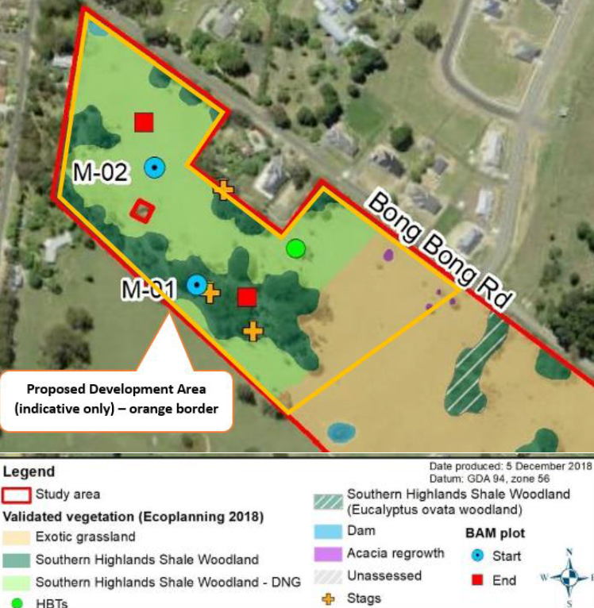  Figure 8: Ecological Constraints Map (Source: Ecological Assessment)
Traffic | The proposed subdivision is likely to result in a modest increase in traffic and access impacts to the local road network. These potential impacts would be assessed in detail by Council at the development assessment stage.  Council considers any potential environmental effects (e.g. traffic) arising from subdivision of the site could be managed through the development application process.
Contamination | The proposal is supported by a Preliminary Contamination Investigation which found the site has a low risk of contamination.  Potential contamination issues would be further assessed in detail by Council at the development assessment stage.

Social and economic
Council considers the planning proposal will have a positive social and economic effect by progressing its strategic planning goals to provide additional housing across the Shire. The planning proposal will assist in ensuring development of the land is undertaken in an orderly and economic manner. Employment will be created during construction.

Infrastructure
Council notes the site is in direct proximity to the residential development of Renwick (to the north) and considers water, sewer and power could be provided along with likely required road upgrade works along Bong Bong Road. Council notes these are issues that could be addressed at the development application/assessment stage.

Community
Council proposes a community consultation period of 28 days.
The exhibition period proposed is considered appropriate and forms the conditions of the Gateway determination.

Agencies
It is recommended the following agencies be consulted on the planning proposal:
- DPIE – Environment, Energy and Science;
- NSW Rural Fire Service; and
- WaterNSW.

Timeframe
Council proposes a 4 month time frame to complete the LEP.
Given the site has environmental constraints, the Department recommends a time frame of 12 months to provide a buffer in case unforeseen issues arise during consultation.
A condition to the above effect is recommended in the Gateway determination.

Local plan-making authority
Council has requested delegation to make the LEP.
As the planning proposal concerns a local matter which is generally in accord with local and regional strategic planning objectives, the Department recommends that Council be authorised to be the local plan-making authority for this proposal.

Assessment summary
It is recommended that the planning proposal proceed as the site has been identified for residential use by Council for some time and is generally consistent with local and regional strategic planning objectives, including adopted Council’s Local Housing Strategy.
It is acknowledged the site has several constraints which appear manageable at this stage and may some further consideration throughout the rezoning and development assessment processes.

Recommendation
It is recommended the delegate of the Secretary:
- agree that any inconsistencies with section 9.1 Direction 1.2 – Rural Zones, Direction 1.5 – Rural Lands and Direction 2.3 – Heritage Conservation are minor or justified; and
- note that the consistency with section 9.1 Direction 4.4 – Planning for Bushfire Protection and Direction 5.2 - Sydney Drinking Water Catchment is unresolved and will require justification.
It is recommended the delegate of the Minister determine that the planning proposal should proceed subject to the following conditions:
- The planning proposal is to be updated prior to public exhibition to:
- include draft LEP Maps;
- address Council’s LSPS.
- Consultation is required with the following public authorities:
- DPIE – Environment, Energy and Science;
- NSW Rural Fire Service; and
- WaterNSW.
- The planning proposal should be made available for community consultation for a minimum of 28 days.
- The timeframe for completing the LEP is to be 12 months from the date of the Gateway determination.
- Given the nature of the proposal, Council should be authorised to be the local plan-making authority.

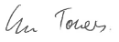2/7/21

Graham Towers
Manager, Southern Region

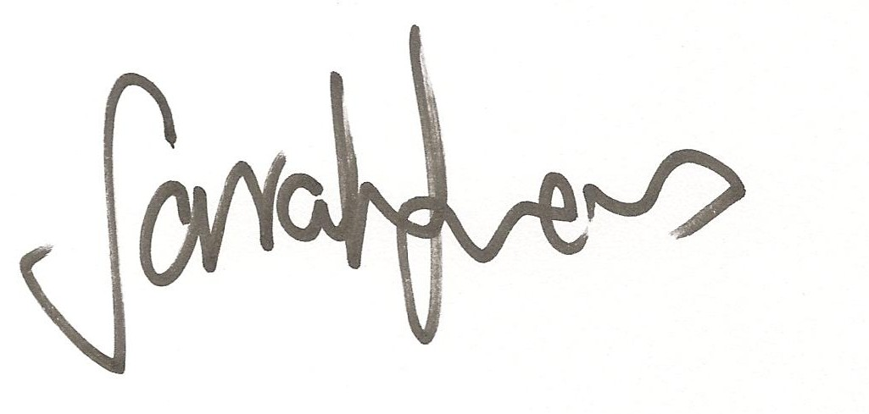2/07/2021

Sarah Lees
Director, Southern Region
Local and Regional Planning

Assessment officer
Andrew Hartcher
Senior Planner, Southern Region
4247 1823

